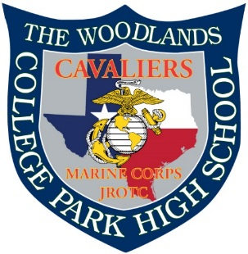
UPDATED INFORMATION
9/01/2019
- Calendar updated with possible drill meets on events page

The Region 5 Drill Championship will be at the Shreveport Convention Center

***BOOK EARLY!! *******BOOK EARLY!! *******BOOK EARLY!! ****

There are numerous events happening that weekend and the hotels will fill up fast and prices will go up.

Hotels near the Convention Center for Regional Drill Competition

Hilton Shreveport – Host Hotel this is where all the Cadets will be staying
104 Market Street, Shreveport, LA
318-698-0900
Connected to Convention Center

https://www3.hilton.com/en/hotels/louisiana/hilton-shreveport-SHVSPHF/index.html?SEO_id=GMB-HI-SHVSPHF

Holiday Inn Express & Suites Shreveport – Downtown
201 Lake Street, Shreveport LA
318-585-1000
.7 miles to Convention Center

https://www.ihg.com/holidayinnexpress/hotels/us/en/shreveport/shvlk/hoteldetail?cm_mmc=GoogleMaps-_-EX-_-US-_-SHVLK

Holiday Inn Shreveport Downtown
102 Lake Street, Shreveport LA
318-222-7717
.7 miles to Convention Center

https://www.ihg.com/holidayinn/hotels/us/en/shreveport/shvdt/hoteldetail?cm_mmc=GoogleMaps-_-HI-_-US-_-SHVDT

Sams Town Hotel & Casino
315 Clyde Fant Parkway, Shreveport LA
877-429-0711
.4 mile to Convention Center

https://www.samstownshreveport.com/

